* Run with docker build command to build a custom Docker image

**cd Docker**

**docker build -t phpcode . -f Dockerfile**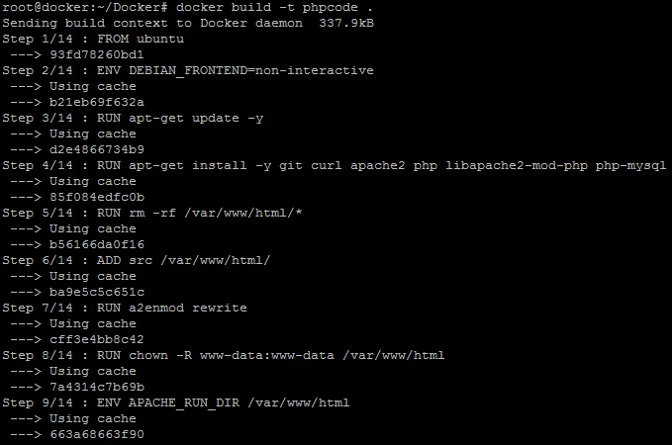

* Once the image is built, check if it is built properly or not. You can see a Docker image entry using Docker images command

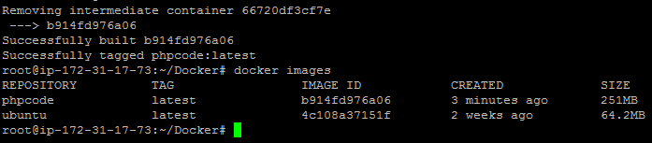

**Step 4.3.3:** Initializing a Docker swarm cluster and deploying a container to the cluster

* First, we need to initialize Docker swarm using the set of commands given below:

**docker swarm init**

**docker node ls**

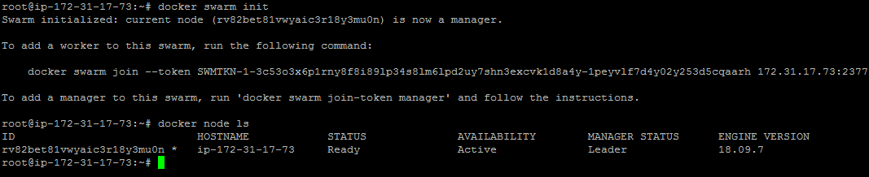

* Once the node is configured, deploy the custom Docker image on the Docker swarm cluster following the process shown below

**docker service create -p 80:80 --name webserver phpcode**

**docker service ls**

**curl localhost**

